**Developing Gap acceptance behavior model for self-driving vehicles using Deep learning framework**

IIT HYDERABAD

Abstract:-

*This study proposes a deep neural network architecture for the* ***Gap acceptance model of self-driving vehicles*** *at* ***unsignalized intersections****. Gap acceptance behavior plays a key role in merging minor road vehicles into the major lane and it is a process that occurs in different traffic situations, such as crossing a road, entering a roundabout, or performing an overtaking maneuver on a bi-directional road. The decision to enter the main lane largely depends on the speed, distance, and heaviness of the potentially conflicting vehicle on the major road. In this paper, the neural network has been built to predict the gap acceptance behavior. The type of major road vehicle and minor road vehicle, speed, and distance of the major lane vehicle in the main lane are the input parameters considered to the ANN’S. This paper analyses the accepted and rejected gaps data collected from a particular Intersection. The results of this analysis can have important implications for road safety.*

**Research work at Vigil lab and at home:-**

Specifically, data has been extracted from 20 videos collected at an unsignalized intersection near IIT hyderabad using cctv footage,AVS video editor is used to get data from traffic videos generated from cctv footage at middle Intersections. ,have worked on preprocessing of data, Class balance analysis is initially performed on the data to create balanced data-set, feature selection technique - filter methods is applied on data because these methods are faster and less computationally expensive than wrapper methods is applied and found that each feature has significance effect on output Dimensionality reduction is not applied to the data variables and then explored on many Artificial neural networks to classify the data.

I got an accuracy of 82% with this model.

VGG net is also applied to this dataset and found that model has been built with accuracy 78%

Adaptive Moment Estimation (Adam) optimizer is used in the model as it rectifies vanishing learning rate, high variance.

**Input data details:-**

**Deep-learning algorithm Implementation(3 layers Neural Network):-**

Input(major lane):- Vehicle type(V1),distance gap(d), speed(real time) of upcoming vehicle(s1).

Input(Minor lane):- Vehicle type(V2),Gap duration

Output(yes or no):-Accepted or rejected.

[Data set](https://docs.google.com/spreadsheets/d/1Vz5KF16UlQSAQHffbW5RplIVzJxNiaYalcSrqaScaUE/edit?usp=sharing)

**Libraries** :-

Keras,Tesorflow.

**Middle Intersection:**

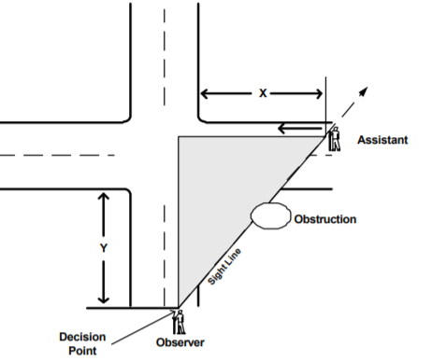

Gap distance has been calculated based on intersection data, each white and black strip is considered as 3 meters, so calculated manually from video, in self-driving vehicles perspective one can easily calculate via image processing.

**Field of view obstructions:-**

IRC recommends a minimum visibility distance of 15 m along the minor road and a distance of 220, 180, 145 and 110 m along the major road corresponding to design speeds of 100, 80, 65 and 60 kmph, respectively.

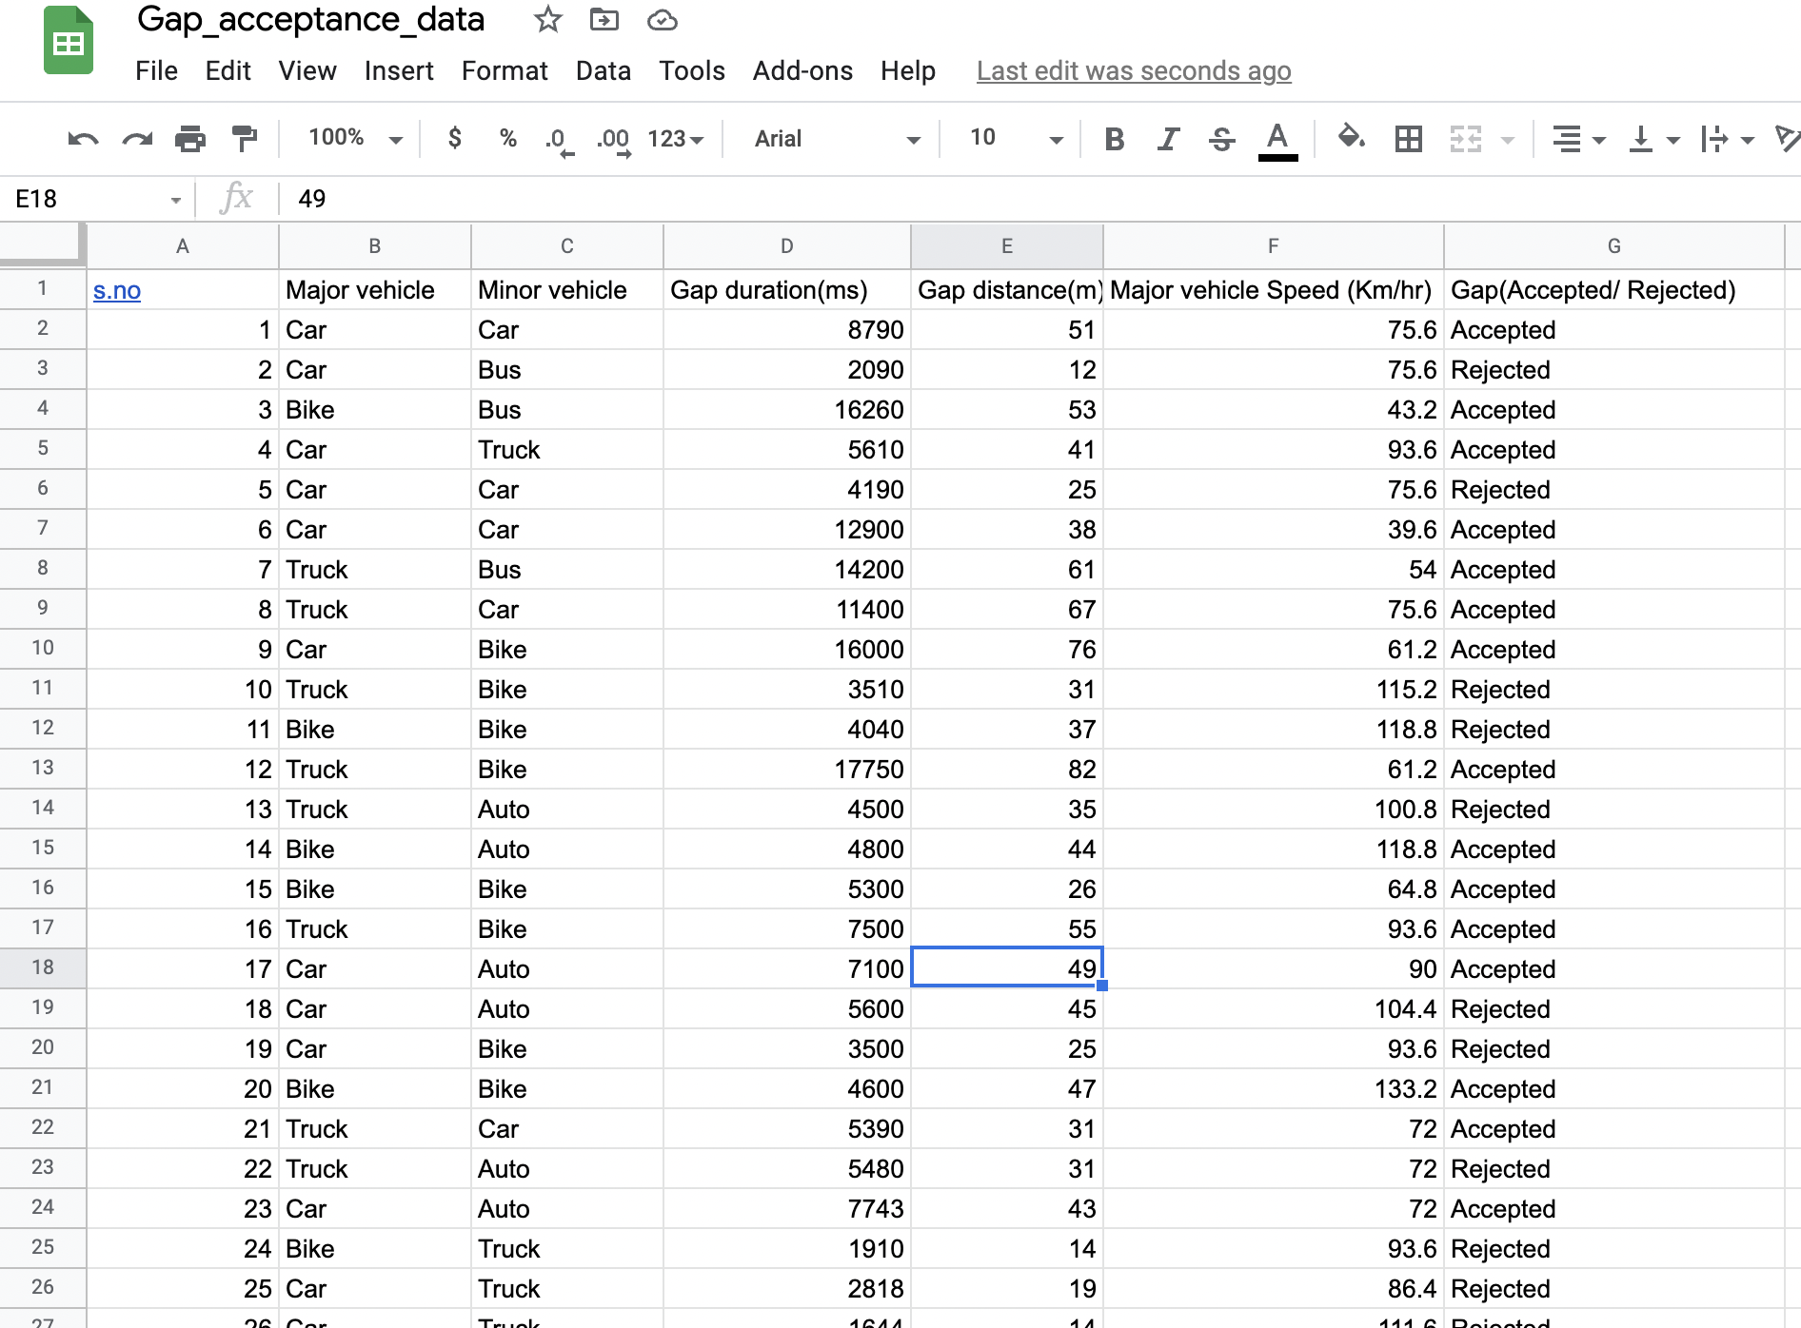

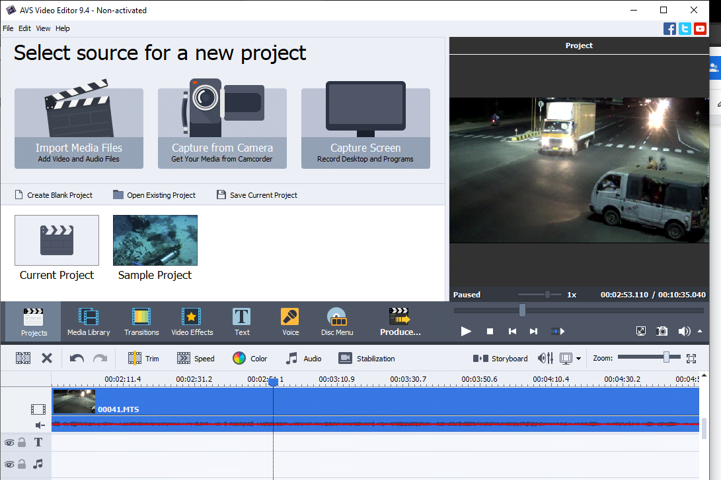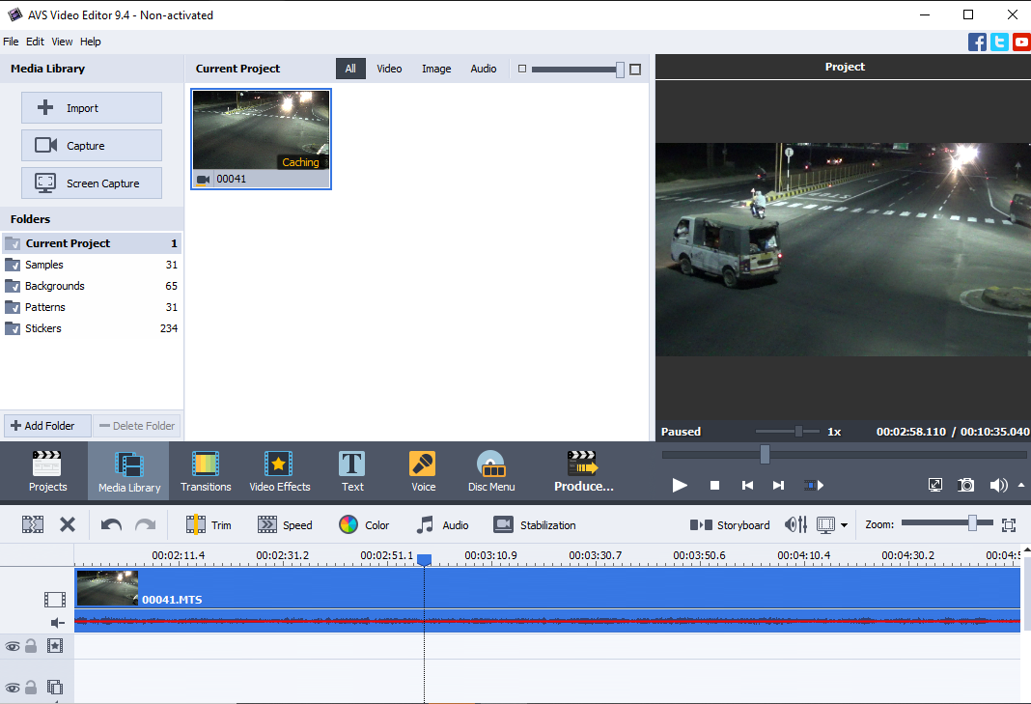

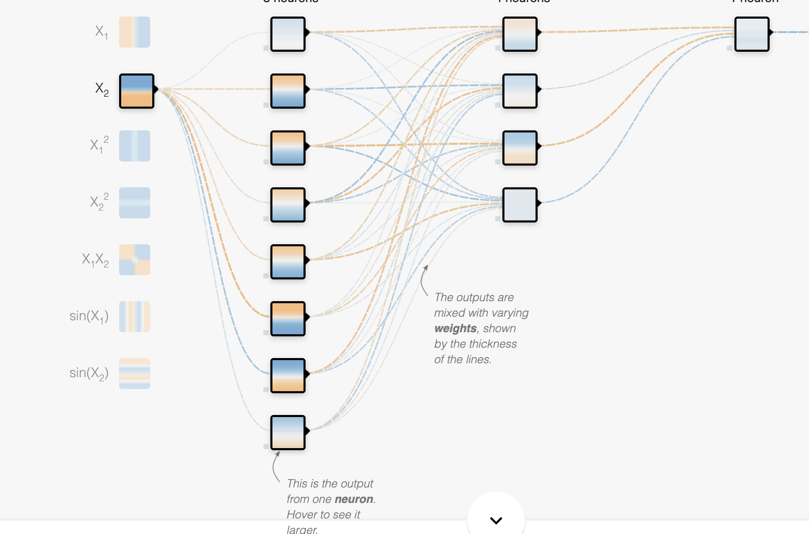

(Major vehicle,Minor vehicle,gap duration,speed,gap length) output(yes or no)

**Literature review**(**A literature review is a comprehensive summary of previous research on a topic**):-

PREVIOUS RESEARCH

* In the previous research supervised learning model has been developed to predict gaps as they have considered the model is independent of the vehicle. Where in the deep learning framework I am going to develop, all the vehicles are included in the model and it works accordingly. The model works differently for each vehicle. Further, this model can be used in self-driving vehicles in traffic. further, I can extend this to relate speed as a dependent variable accordingly and include the speed of the coming vehicle in the deep learning framework. Now I would like to develop a model using a deep learning framework with increased efficiency.

(<https://www.researchgate.net/profile/Digvijay_Pawar/publication/317547393_Analyzing_Gap_Acceptance_Behavior_at_Unsignalized_Intersections_Using_Support_Vector_Machines_Decision_Tree_and_Random_Forests/links/5950c2d40f7e9be7b2e8231f/Analyzing-Gap-Acceptance-Behavior-at-Unsignalized-Intersections-Using-Support-Vector-Machines-Decision-Tree-and-Random-Forests.pdf>)

* A journal on Gap-Acceptance Problems at a Traffic Intersection has been published earlier

(<https://www.jstor.org/stable/2346461?Search=yes&resultItemClick=true&searchText=gap%20acceptance%20behaviour&searchUri=%2Faction%2FdoBasicSearch%3FQuery%3Dgap%2Bacceptance%2Bbehaviour%26acc%3Doff%26wc%3Don%26fc%3Doff%26group%3Dnone&ab_segments=0%2Fbasic_SYC-5187_SYC-5188%2F5187&refreqid=fastly-default%3A625f1d6ba16d55461190d2fa80d9c6de&seq=1>)

* This journal basically Analysis the Gap-Acceptance in Traffic

(<https://www.jstor.org/stable/2347055?Search=yes&resultItemClick=true&searchText=gap%20acceptance%20behaviour&searchUri=%2Faction%2FdoBasicSearch%3FQuery%3Dgap%2Bacceptance%2Bbehaviour%26acc%3Doff%26wc%3Don%26fc%3Doff%26group%3Dnone&ab_segments=0%2Fbasic_SYC-5187_SYC-5188%2F5187&refreqid=fastly-default%3Ab42b1a55a0c990321da3c72052df4d5c&seq=1>)

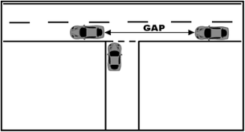

**Results and Analysis** :-

Why is ML used here?

* To find the nonlinear **relationships** between dependent and independent variables.
* It is not possible for a human to predict exact nonlinear **relationships** between dependent and independent variables so taking help from ML to get accurate results
* So, training here with 75% of data we have to get weights, later on using the remaining data(25%) to test the model.
* Total data sets are 350 , test data - 262, train data -88

Achieved efficiency of 82% through this Trained model

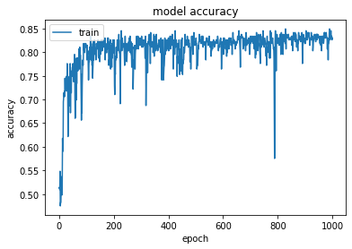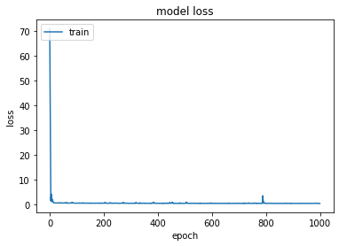

CODE

[Link to google colab](https://colab.research.google.com/drive/1gVr8Q8RvnMaA_Vx0x-ynjFzr5YYWW3J2?usp=sharing)

**Inference**

Through the above trained model ,deep learning framework , one can easily find whether to accept the gap or not without much human effort. VGG net is also applied to the data set which resulted in less accuracy

**Acknowledgement:-**

I would like to thank K.Naveen kumar for allowing me to explore different deep learning networks. Overall, it is a nice learning experience.